Yanzhao Yang

Use Case: member updating profile page
Id: UC2
Brief Description:
After visitor entered into profile page, he/she can update personal information, work information, education information, project description, and upload portrait.
Actors:
Visitor
Preconditions:
1. The visitor should be a registered member.
Main Flow:
- The use case begins with the visitor logged in the web site by user id and password.
- The visitor uploads a picture as head portrait. On the top of the profile page, the left side is a portrait position. Visitor can click "upload" button, open a dialogue control, choose one photo as portrait, click" OK" button.
- The visitor updates account information. There are account information field. The visitor click "Edit" button, then the visitor can edit personal information, such as user id, password. There are three password textbox including one for tying old password, two for typing new password.
- The visitor can update personal information. Below account field, there are personal information field including many textbox. The visitor click "Edit" button, then the visitor can edit personal information, such as name, address, phone number, and so on.
- In the same way, the visitor can edit the education information (including student id, school name, major, start date, end date), work information (including company, position, description, start date, end date) and project description.
- Besides, visitor can add description for project and modify member list of a specific project.
- Finally, the visitor click the bottom button “saves" to finish all actions.
Post conditions: The system has updated the database associated with the member’s education information, personal information, work information, member list information and project information.
Alternative Flows: At any time, the visitor can click on the “cancel button”(at the bottom of the page) to quit and the data would not be saved.

Table of Analysis for Class Selection
Number | Candidate Noun | Is a class? | Justification
1 | Account | Yes | Registered users can view and update account info, such as userid, password
2 | UserId | No | Attribute data
3 | Password | No | Attribute data
4 | PersonInfo | Yes | Users can do action such as fill out name, address, phone number
5 | Name | No | Attribute data
8 | Address | No | Attribute data
9 | Phone | No | Attribute data
10 | EduactionInfo | Yes | Users can update their school name , school id start or end date
11 | StudentId | No | Attribute data
12 | School | No | Attribute data
13 | Major | No | Attribute data
14 | Start date | No | Attribute data
15 | End date | No | Attribute data
16 | WorkInfo | Yes | User can update work history information
17 | Company | No | Attribute data
18 | Position | No | Attribute data
19 | Descrption | No | Attribute data
20 | Start date | No | Attribute data
21 | End date | No | Attribute data
22 | ProjectIfo | Yes | Users can update current project or old project information
23 | MemberList | No | Attribute data
24 | Project Description | No | Attribute data
25 | Contacts | No | Attribute data
26 | Demo | No | Attribute data

Number | Class Name | Description of the class
1 | Account | An entity created after a visitor has registered as a membership. It includes user name, password, etc.
2 | PersonaInfo | An entity created after a visitor has registered as a membership. It provides all personal information including name , phonenumber, address, etc.
3 | EducationInfo | An entity that represents the education information of a user, including student id, school, major, enrollment time, graduate time,
 | WorkInfo | An entity that represents the work information of a user, including work id, company, position, description, start date, end date.
4 | ProjectInfo | An entity that represents the project information developed or participated by a user. It provides project name, platform, description, memberlist, date, time, demo and followers.

Profile Page
Profile page is supposed to display a list information (personal, education, work, user pictures )of registered users. And it will show the descriptions of current project the user is working for, contact information and member list of that project.
Figure 1 Profile Page Design
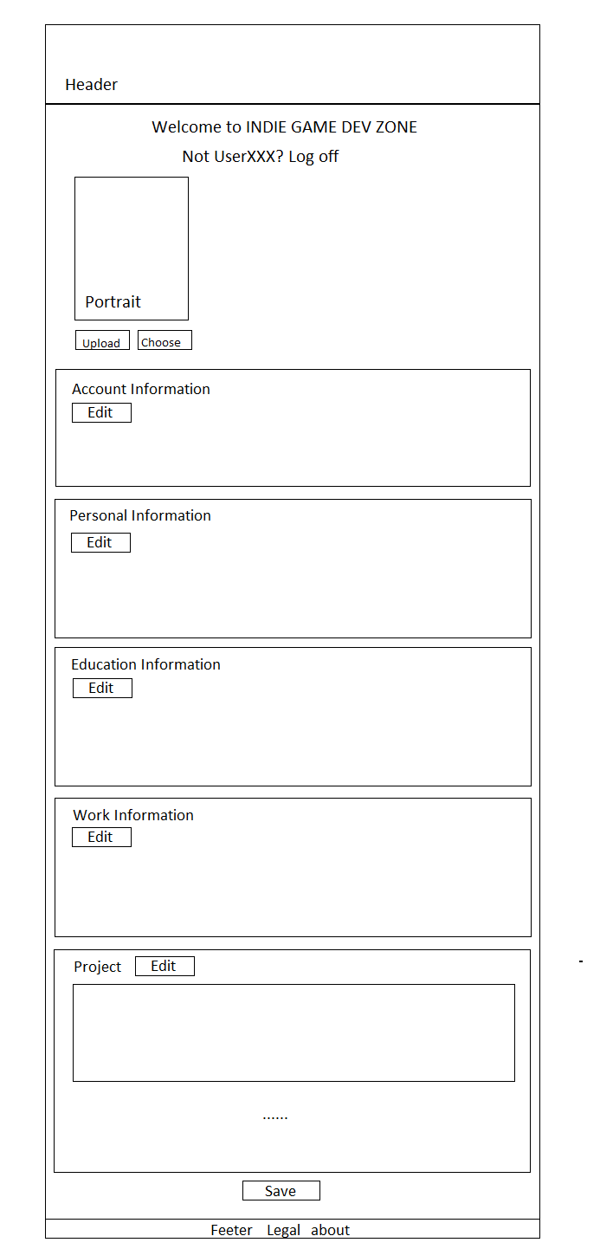

Figure 2 Screen Shot
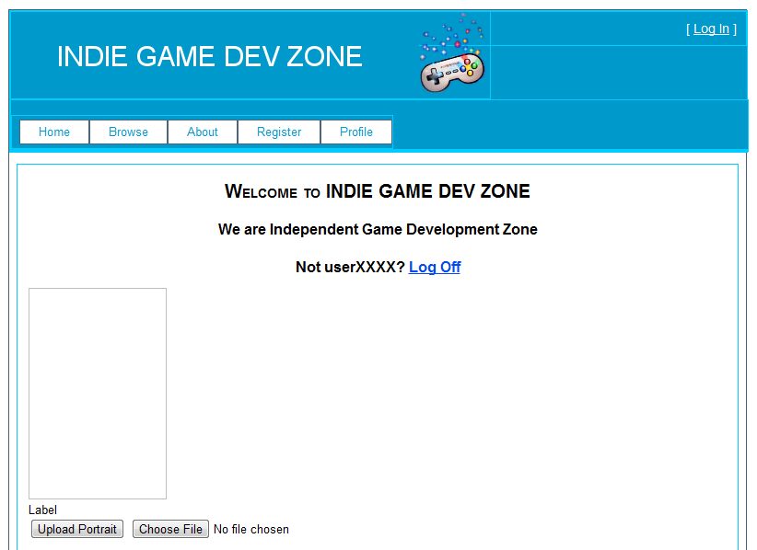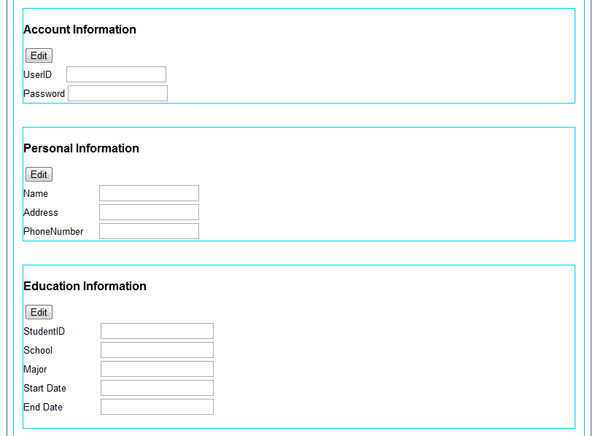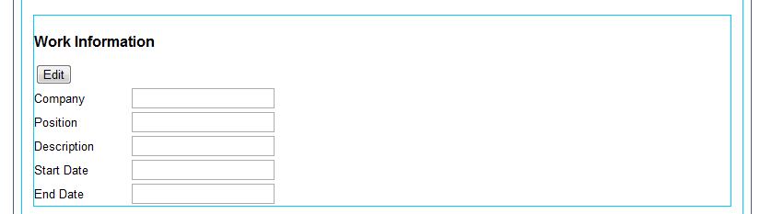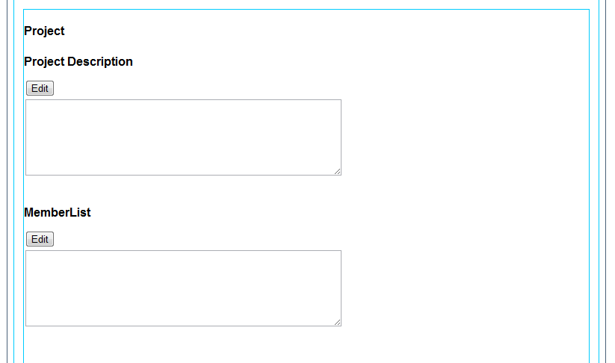
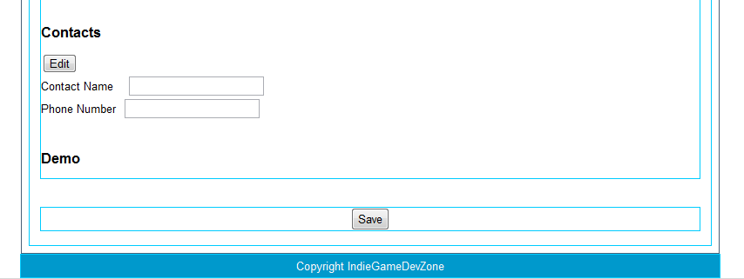
The above figure are the design and screen shot of profile page The header is the uniform head of web site, there are some button which make user easy to move to other pages.
Then, there is a welcome sentence including tips” Not userXXX? Log off”. If the person is not the user, he can click the hyperlink “Log off” to leave this page.
Below the header, there is portrait, user can upload a portrait by click that button.
Following that, there are lists of information section (account, personal, work, project).When users enter this page, they can view the current information inherited from database. When they click “Edit” button in different section, the related textbox in specific section will be able to edit, they can update related information. After edition, user can click “Save” button to save updated information. Then the page will become a view page (all textbox become disabled) again. Right now, there are only a few items in sections. We will add more items later, such as change password or find password back in account section, and project start date, project vote, in project section.
Besides, we may open an area which might also be dedicated to project sponsors, such as a particular school of UTD or even companies that choose to sponsor or fund a project.

